ЛАБОРАТОРНА РОБОТА №7
Тема: Реалізація гри Тетріс
Мета роботи: вивчити особливості реалізації ООП в прототипному стилі у мові програмування JavaScript; навчитися реалізовувати наслідування у JavaScript. Реалізувати гру тетріс за допомогою ООП
Завдання 1
Реалізувати гру тетріс за допомогою ООП
Код:
Index.html:
<!DOCTYPE html>
<html lang="en">
<head>
<meta charset="UTF-8">
<title>TETRIS</title>
<link rel="stylesheet" href="style.css">
</head>
<body class="body">
<audio loop='loop' autoplay='autoplay' hidden='hidden'>
<source src="song.mp3" type="audio/mpeg"/>
</audio>
<div id="score"></div>
</body>
<script src="script.js"></script>
</html>
Script.js:
var keyController = {
LEFT: 37,
UP:38,
RIGHT: 39,
DOWN: 40,
};
function BoardController(width, height, squareWidth){
this._width = width;
this._height = height;
this._squareWidth = squareWidth;
this._canvasWidth = width * squareWidth;
this._canvasHeight = height * squareWidth;
this._matrix = this.createBoard();
}

BoardController.prototype.createBoard = function () {
const matrix = [];
let height = this._height;
while (height--){
matrix.push(new Array(this._width).fill(0));
}
return matrix;
};
TetrisController.COLORS = [null, 'red', 'blue', 'violet','green','purple','orange', 'pink'];
function TetrisController(element, boardController, dropInterval, player) {
this._element = element;
this._board = boardController;
this._canvas = null;
this._context = null;
this._lastTime = 0;
this.player = player;
this._dropCounter = 0;
this._dropInterval = dropInterval;
this._init();
}
TetrisController.prototype._init = function () {
const canvas = document.createElement('canvas');
canvas.setAttribute('width',this._board._canvasWidth);
canvas.setAttribute('height',this._board._canvasHeight);
this._element.appendChild(canvas);
this.playerReset();
this._canvas = canvas;
this._context = canvas.getContext('2d');
};
TetrisController.prototype.startGame = function () {
this.updateScore();
this._update();
};
TetrisController.prototype._update = function (time = 0) {
var self = this;
let deltaTime = time - self._lastTime;
self._lastTime = time;
self._dropCounter += deltaTime;
if (this._dropCounter > this._dropInterval){
self.playerDrop();
}
self.draw();
requestAnimationFrame(function(time){self._update(time)});
};
TetrisController.prototype.draw = function () {
this._context.fillStyle = '#c8ebfc';
this._context.fillRect(0, 0, this._canvas.width, this._canvas.height);
this.drawMatrix.call(this, this._board._matrix, {x: 0, y: 0});
this.drawMatrix.call(this, this.player.figure, this.player.position);
};
TetrisController.prototype.drawMatrix = function (matrix, offset) {
var self = this;
matrix.forEach(function (row, y) {
row.forEach(function (value, x) {
if (value !== 0){
self._context.beginPath();
self._context.fillStyle = TetrisController.COLORS[value];
self._context.rect((x + offset.x)* self._board._squareWidth, (y + offset.y) * self._board._squareWidth , self._board._squareWidth, self._board._squareWidth);
self._context.fill();
self._context.stroke();
}
});
});
};
TetrisController.prototype.playerReset = function () {
const pieces = 'ILJOTSZ';
this.player.figure = this.player.createPiece(pieces[pieces.length * Math.random() | 0]);
this.player.position.y = 0;
this.player.position.x = (this._board._matrix[0].length / 2 | 0) - (this.player.figure[0].length / 2 | 0);
if(this.collide(this._board._matrix, this.player)){
this._board._matrix.forEach(function (row) {
row.fill(0);
});
this.player.score = 0;
}
};
TetrisController.prototype.collide = function (arena, player) {
const [m, o] = [player.figure, player.position];
for(let y = 0; y < m.length; y++){
for(let x = 0; x < m[y].length; x++){
if(m[y][x] !==0 &&
(arena[y + o.y] &&
arena[y + o.y][x + o.x]) !== 0){
return true;
}
}
}
return false;
};
TetrisController.prototype.playerDrop = function () {
this.player.position.y++;
if(this.collide(this._board._matrix, this.player)){
this.player.position.y--;
this.merge(this._board._matrix, this.player);
this.playerReset();
this.arenaSweep();
this.updateScore();
}
this._dropCounter = 0;
};
TetrisController.prototype.merge = function (arena, player) {
player.figure.forEach(function (row, y) {
row.forEach(function (value, x) {
if(value !== 0){
arena[y + player.position.y][x + player.position.x] = value;
}
});
});
};
TetrisController.prototype.playerMove = function(dir) {
this.player.position.x += dir;
if(this.collide(this._board._matrix, this.player)){
this.player.position.x -= dir
}
};
TetrisController.prototype.playerRotate = function () {
let pos = this.player.position.x;
let offset = 1;
this._rotate(this.player.figure, 1);
while (this.collide(this._board._matrix, this.player)) {
this.player.position.x += offset;
offset = -(offset + (offset > 0 ? 1 : -1));
if (offset > this.player.figure[0].length) {
this._rotate(this.player.figure, -1);
this.player.position.x = pos;
return;
}
}
};
TetrisController.prototype._rotate = function (matrix, dir) {
for(let y = 0; y < matrix.length; y++){
for(let x = 0; x < y; x++){
[matrix[x][y], matrix[y][x]] = [matrix[y][x], matrix[x][y]];
}
}
if(dir > 0){
matrix.forEach(function (row) {
row.reverse();
});
} else {
matrix.reverse();
}
};
TetrisController.prototype.arenaSweep = function () {
let rowCounter = 1;
outer: for(let y = this._board._matrix.length - 1; y >= 0; y--){
for(let x = 0; x < this._board._matrix[y].length; x++){
if(this._board._matrix[y][x] === 0 ){
continue outer;
}
}
const row = this._board._matrix.splice(y, 1)[0].fill(0);
this._board._matrix.unshift(row);
y++;
this.player.score += rowCounter * 10;
rowCounter *= 2;
}
};
TetrisController.prototype.updateScore = function () {
document.getElementById('score').innerHTML = this.player.score;
};
function Player (vector2, figure, score) {
this.position = vector2;
this.figure = figure;
this.score = score;
}
Player.prototype.createPiece = function (type) {
if (type === 'T'){
return [
[0, 0, 0],
[1, 1, 1],
[0, 1, 0]
];
} else if (type === 'O'){
return [
[2, 2],
[2, 2],
];
} else if (type === 'L'){
return [
[0, 3, 0],
[0, 3, 0],
[0, 3, 3]
];
} else if (type === 'J'){
return [
[0, 4, 0],
[0, 4, 0],
[4, 4, 0]
];
} else if (type === 'I'){
return [
[0, 5, 0, 0],
[0, 5, 0, 0],
[0, 5, 0, 0],
[0, 5, 0, 0],
];
} else if (type === 'S'){
return [
[0, 6, 6],
[6, 6, 0],
[0, 0, 0]
];
} else if (type === 'Z'){
return [
[7, 7, 0],
[0, 7, 7],
[0, 0, 0]
];
}
};
function Vector2 (x, y) {
this.x = 0;
this.y = 0;
}
var tet = new TetrisController(document.body, new BoardController(12,20,20),1000,new Player(new Vector2(0, 0), null, 0));
tet.startGame();
document.addEventListener('keydown',function (event) {
if(event.keyCode===keyController.LEFT){
tet.playerMove(-1);
} else if (event.keyCode === keyController.RIGHT){
tet.playerMove(1);
} else if (event.keyCode === keyController.DOWN){
tet.playerDrop();
} else if (event.keyCode === keyController.UP){
tet.playerRotate();
}
});
style.css
body {
background: #2a2a32;
color: #fff;
font-family: sans-serif;
font-size: 2em;
text-align: center;
}
canvas {
border: solid .2em #fff;
height: 90vh;
}
Виконання:
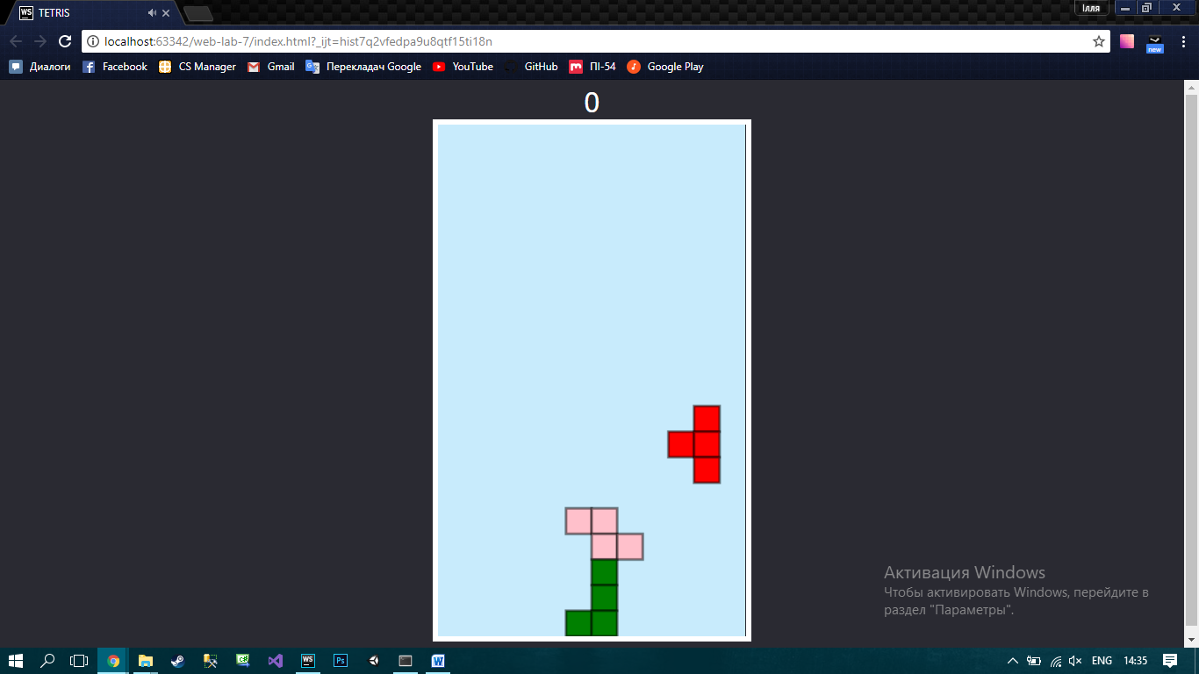
Рисунок 1 – приклад виконання
Висновок: вивчив особливості реалізації ООП в прототипному стилі у мові програмування JavaScript; навчився реалізовувати наслідування у JavaScript. Реалізував гру тетріс за допомогою ООП

